R LAB EXPERIMENTS
1.Create numeric, character, and logical vectors and display type and content.
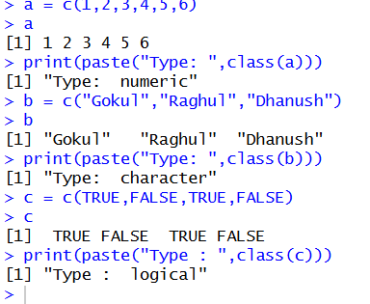
a = c(1,2,3,4,5,6)
a
print(paste("Type: ",class(a)))
b = c("Gokul","Raghul","Dhanush")
b
print(paste("Type: ",class(b)))
c = c(TRUE,FALSE,TRUE,FALSE)
c
print(paste("Type : ",class(c)))

2.Create labeled matrices (5×4, 3×3, 2×2) filled by row/column.
a = matrix(1:20,nrow=5,ncol=4)
a
b = matrix(1:9,nrow=3,ncol=3)
b
c = matrix(1:4,nrow=2,ncol=2)
c
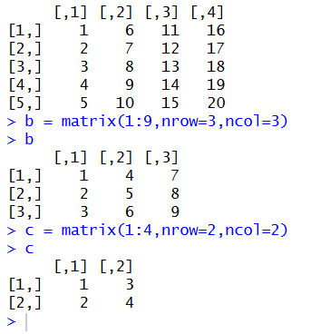

3. Write an R program to create and display a 3D array with specified rows, columns, and tables.
a = 1.24
arr = array(a, dim=c(2,3,4))
arr
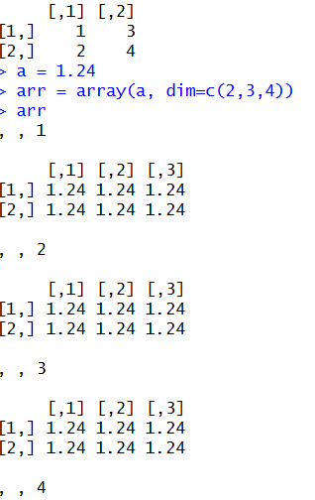

4. Create arrays from vectors with dimension names, print specific elements.
a = 1:8
b = array(a, dim=c(2,2,2))
b
print(b[2,1,2])

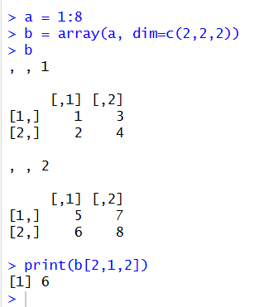

5. Create and manipulate factor variables (e.g., women’s dataset heights, random LETTERS sample)
a = c("Short","Medium","Tall","Medium","Tall","Short")
b = factor(a)
print(b)
set.seed(10)
c= sample(LETTERS[1:5],8,replace = TRUE)
d = factor(c)
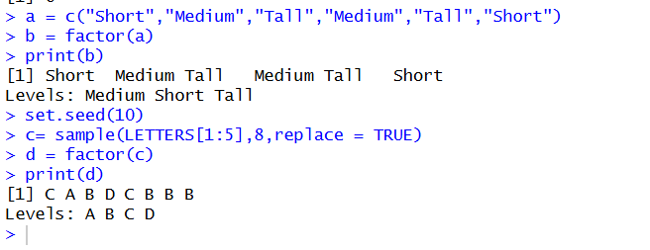
print(d)

